**Level 1: PC Tower Case**

**Outline**

Learn about the internals of a standard PC case by examining physical samples and selecting and labeling images found on-line. Gain deeper knowledge by researching and reporting on specific components.

**Questions**

1. Find one (or more) images that clearly show the internals of a PC Tower Case.   
   (i.e. Google images using keywords “PC Case Internals”)  
   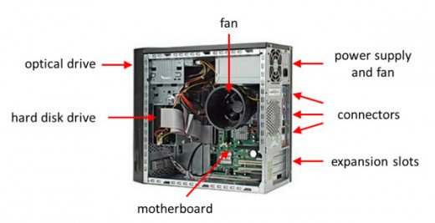

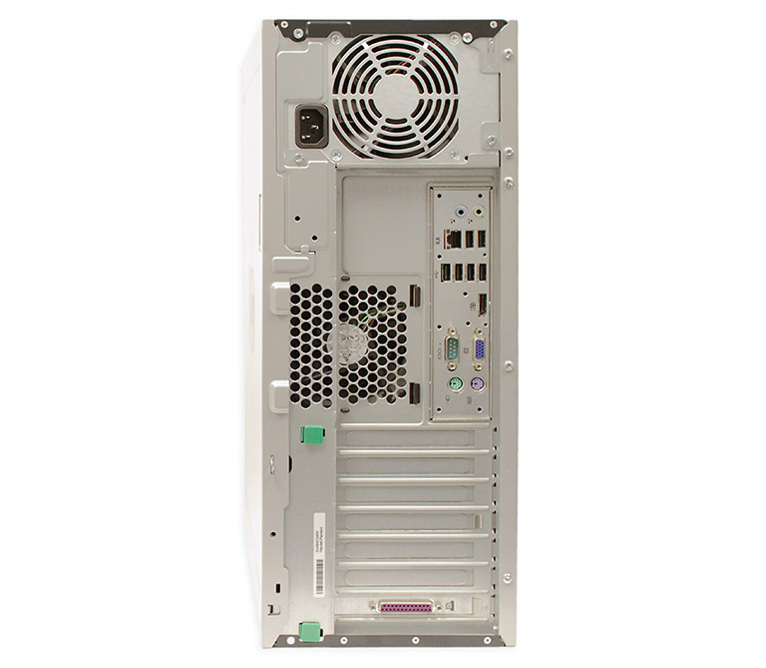

Monitor Port

Ethernet Port

USB Port

Audio Port

1. Clearly label the following components (using arrows) on your image of the PC case internals:
   1. Motherboard
   2. Power Supply
   3. Hard Disk Drive
   4. Optical Disk Drive (e.g.DVD)
   5. USB Expansion Ports
   6. Monitor Port
   7. Audio Ports
   8. Ethernet Port
   9. Cooling Fan
2. Research more in-depth about “Motherboards”. Make notes on the following:
   1. What different versions are currently available (speed and capacity)

Motherboards come in different sizes which are known as form factors. The most common form factor is called the ATX. A smaller form factor is the ITX which comes in mini-ATX , nano-ATX, and pico-ATX size. A motherboards speed is called the Bus Speed which describes how fast a computer can move data from one computer component to another. Speeds can range from 66MHz to over 800MHz. MHz means megahertz which is one million cycles per second.

* 1. How the component has changed since the 1980’s

The first motherboards had very few components. The first IBM PC motherboard only had a processor and card slots. Now, motherboards have a variety of built-in features and they directly affect a computers capability. Additionally, motherboards feature a lot of accessories like video, sound support etc.

“How Motherboards Work.” *HowStuffWorks*, HowStuffWorks, 20 July 2005, computer.howstuffworks.com/motherboard.htm.

1. Research more in-depth about “Hard Disk Drives”. Make notes on the following:
   1. What different versions are currently available (speed and capacity)

The currently available types of hard drives can be grouped into four types;

* PATA (data transfer up to 133MB/s and max 2 devices connect)
* SATA (600MB/s)
* SCSI ( 320MBps)
* SSD (712MB/s)
  1. How the component has changed since the 1980’s  
       
     Since the first hard drives were introduced, we have moved from 5MB of refrigerator size hard drives to 4TB pocket sized SSD. In 1980 IBM gave us the first hard disk with a capacity of 1 GB. Smaller but still as big as a single refrigerator it weighed in at 300 pounds. In 2007, Hitachi was the first company to reach the 1 TB barrier. Five years later, hard disks with a capacity of 4 TB were created. To summarize, hard drives have gotten smaller with increasing capacity.

**NOTE:**

* Download the on-line version of this module (from the class GitHub repository)
* Questions for Level 2 and Level 3 are in the on-line version of this module
* Provide your answers in a MS Word, PowerPoint, or equivalent format
* Upload your answers to your personal GitHub repository

**Level 2: PC Motherboard**

**Outline**

Learn about the structure of a standard PC motherboard by examining physical samples and selecting and labeling images found on-line. Gain deeper knowledge by researching and reporting on specific components.

**Questions**

1. 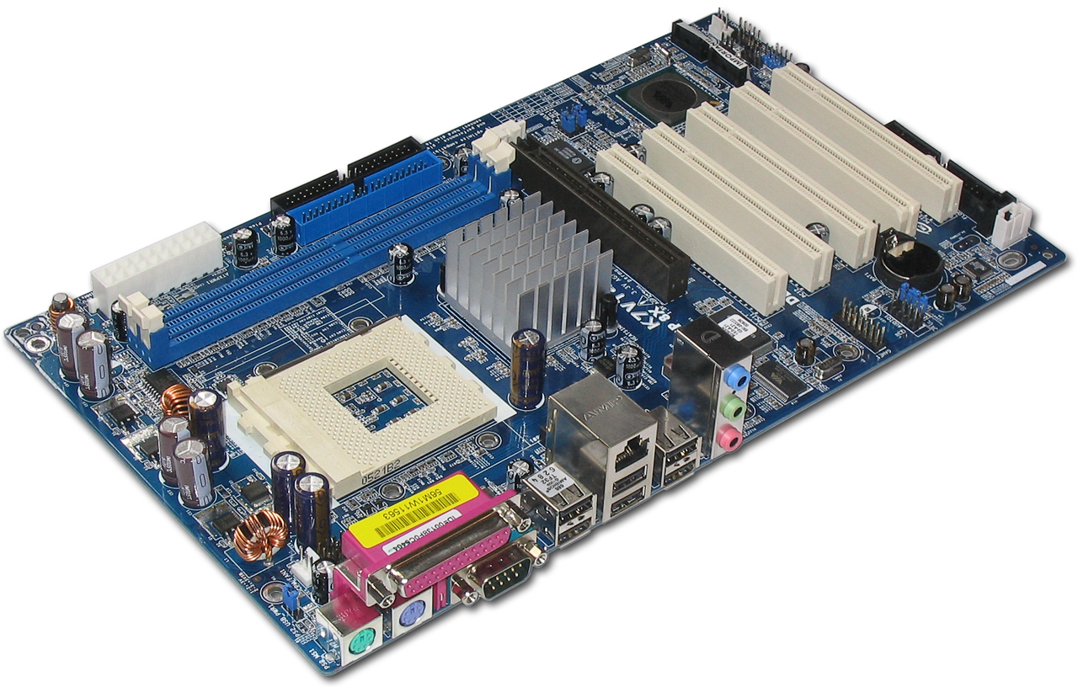Find one (or more) images that clearly show the layout of a PC Motherboard.   
   (i.e. Google images using keywords “PC Motherboard”)  
     
   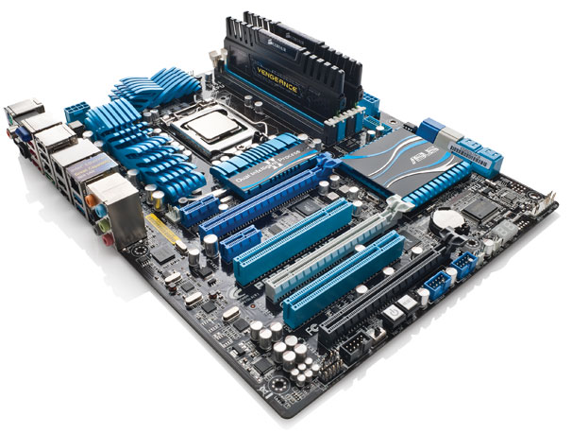

GPU

Ethernet

Sound Processor

IDE

CPU

RAM

1. Clearly label the following components (using arrows) on your image of the PC motherboard:
   1. CPU (and fan)
   2. RAM Memory
   3. Disk Drive Interface (IDE or SATA)
   4. GPU Graphics Processor (either on-board or Graphics Card)
   5. Sound Processor (either on-board or Sound Card)
   6. Wi-Fi / Ethernet Network Interface (either on-board or Graphics Card)

1. Research more in-depth about “CPU Processor Chip”. Make notes on the following:
   1. What different versions are currently available (speed and capacity)

There are many different versions but the manufacturers that are in the lead in terms of speed and quality are Intel and AMD. Intel’s desktop CPUs include Celeron (1,4GHz), Pentium (4.5GHz) and Core (3.0 GHz). AMD’s include Sempron (2.9 GHz), Athlon(2.4GHz) and Phenom (2.6GHz).

* 1. How the component has changed since the 1980’s?

Well, an example to show the evolution of processors since the 1980s is Intel. Their closest release to 1980 was in 1978 when they released the Intel 8086 which was a 16-bit microprocessor. Recently, Intel release Corei7, which they describe as “a family of high-end performance 64-bit processors”. Some of these reach 5GHz. In comparison, the older version reached only 5MHz.

1. Research more in-depth about “RAM Memory”. Make notes on the following:
   1. What different versions are currently available (speed and capacity)

The two widely used versions today are SRAM and DRAM. Typically, SRAM is faster than DRAM. When it comes to capacity, diffen.com states that the number of transistors in a memory device determines its capacity. Therefore, since SRAM require 6 transistors and DRAM only requires 1, a DRAM has 6 times more capacity than a SRAM.

“SRAM vs DRAM.” *Mountain Bike vs Road Bike - Difference and Comparison | Diffen*,

www.diffen.com/difference/Dynamic_random-access_memory_vs_Static_random-access_memory#Capacity_and_Density.

* 1. How the component has changed since the 1980’s  
       
     In the 1980s, computers did not exceed even 2Mb of memory. BY 2005, 2GB was the standard. Since 2010, it has been 6GB-48GB.

**Level 3: Peripheral Devices**

**Outline**

Learn about how peripheral devices are connected to the back side of a typical PC tower case. Examine physical samples, select and labeling images found on-line and gain deeper knowledge by researching and reporting on specific components.

**Questions**

1. Find one (or more) images that clearly show the layout of the back of a typical PC tower case.   
   (i.e. Google images using keywords “Back Of PC Tower”)  
     
   

Power Socket

Mouse (PS/2)

Keyboard (PS/2)

USB Ports

Ethernet Port

AUDIO PORTS

Monitor Port

1. Clearly label the following components (using arrows) on your image of the back of a typical PC tower case:
   1. Power cord and power switch
   2. Monitor Interface (VGA or DVI or HDMI)
   3. Mouse Interface (USB or PS/2)
   4. Keyboard Interface (USB or PS/2)
   5. USB Ports
   6. Audio Inputs / Outputs
   7. Ethernet Interface

1. Research more in-depth about “Monitor Technology”. Make notes on the following:
   1. What different versions are currently available (e.g. VGA / DVI, Flat Panel Technology)

VGA- stands for a Video Graphics Array. It is the connector that is provided on many video cards, computer monitors, laptop computers, projectors, and television sets.

DVI- stands for Video Display Interface. It is used to connect a video source like a video controller to a display device such as a computer monitor.

Flat Panel Technology- a television, monitor, or other display that uses a thing panel deisgn. These screens are lighter, thinner, and more portable.

* 1. How the component has changed since the 1980’s (e.g. Display Resolution, Technology)

The technology for liquid crystal displays has been around since the 1970s and was usually found in watches, clocks, and home appliances. In the 80s, home computers were new. For example, the first Mac became available to people with a 9-inch, monochrome 512×342 pixel display compared to today's Mac with Retina 5K, a 5,120x2,880 pixel display that supports millions of colors. In the 1990s, the primary use of LCD technology was found in laptops due to the display's lower power consumption, smaller size, and lighter weight. As LCD technology improved, LCD screens soon became more popular in desktop monitors and televisions. Currently, most desktop displays used LCD or CRT technology. Resolution which is affected by the size of the screen is higher.

1. Research more in-depth about “External Portable Storage”. Make notes on the following:
   1. Floppy Disks- type of disk storage that is made up of a disk that is flexible and magnetic, sealed inside a plastic rectangle. These disks are read by a floppy disk drive.
   2. CD-ROM – A CD that can be read by a computer with an drive. ROM means that the data on the disk can be read but not altered or erased

DVD – type of disc able to store large amounts of data with high resolution

Recordable CD/DVD – blanks that can be used to store data

* 1. USB Memory Drives- small external flash drive that can be used with any computer that has USB port
  2. Compact Flash Memory- memory card format that stores data on a small portable card called a CF card
  3. Cloud Based Storage- data that is stored using servers that can be accessed from the internet or the “cloud”.

**Level 4: PC Component Presentation**

**Outline**

Explore the development and features of a specific PC hardware component through deeper research and investigation. Work in partners to create a short presentation. Deliver the presentation to the class.

Each group will research a unique PC hardware component . Your specific topic will be assigned from the list provided below.

**Presentation Structure**

1. Explain what the PC component does and how it fits together with other components to make up a fully functioning PC.
2. Explain how the PC component works. Provide a diagram (image) showing the main parts of the component.
3. Research the current state of the art of the component in terms speed, capacity (size), and other related factors.
4. Research on-line suppliers that sell the PC Component. List the specifications for the available products and the cost (price).
5. Research how the PC component has changed and evolved since the early days of PCs in the 1980’s. Cover each of the following topics separately:
   1. Component Speed
   2. Component Size / Capacity
   3. Two other specifications specific to the PC component (ask Mr. Nestor)

**PC Component Topics**

|  |  |  |
| --- | --- | --- |
| **Topic** | **Partner 1** | **Partner 2** |
| CPU Microprocessor Chip |  |  |
| Motherboard Layout |  |  |
| Computer Graphics |  |  |
| Sound & Audio |  |  |
| Hard Disk Drives |  |  |
| Removable Disk Storage |  |  |
| Network / Internet Connectivity |  |  |
| Mouse / Pointing Devices |  |  |
| Monitor & Display Technology |  |  |
| Printers & Output Technology |  |  |